New Mexico Chapter
American Academy of Family Physicians
PO Box 6098, Albuquerque, NM 87197
(505) 292-3113 | familydoctor@newmexico.com | www.familydoctornm.org

APPLICATION FOR EXHIBIT SPACE

Please reserve space for your exhibit at the:
67th Annual NMAFP Family Medicine Seminar
Exhibit Days: Thursday, August 7 and Friday, August 8, 2025
Ruidoso Convention Center, Ruidoso, NM
Melissa Martinez, M.D., Scientific Program Chair

Fee for Exhibiting Thursday and Friday: $1,300

If a vendor wishes to eat the food served in the Exhibit Hall, a meal ticket, which includes two breakfasts, two lunches, and two breaks, must be purchased at the time of registration at a cost of $250 per person. Vendor name badges will indicate meal ticket purchase.
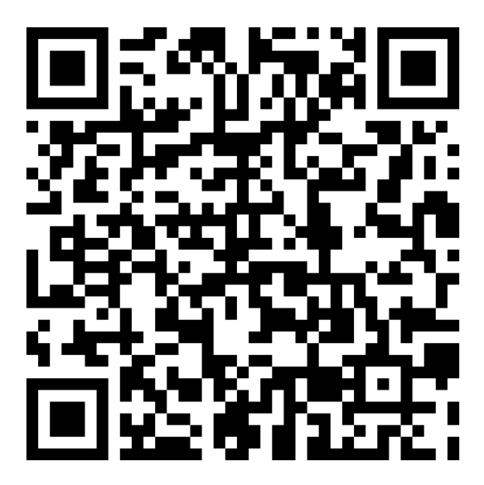

Payment is due no later than July 25, 2025 | Tax I.D. #85-0309166

Register Online: www.familydoctornm.org/summer-exhibitor-registration

Exhibitor: Please complete, sign, and return this application to the New Mexico Chapter of the American Academy of Family Physicians, Inc. to PO Box 6098, Albuquerque, NM 87197.

Firm Name_____________________________________________________________________________________

Your Name____________________________________________________________________________________

Address_______________________________________________________________________________________

City/State/Zip___________________________________________________________________________________

Telephone________________________ Email Address__________________________________________________

Names of all Vendors Attending____________________________________________________________________

______________________________________________________________________________________________

Do you need meal tickets for any vendors named above ($250 per person)? __________________________________

We understand that this application becomes a contract when signed by us and accepted by the Chapter. We agree to abide by the conditions of the contract included with this application.

Name________________________________Signature________________________________Date_____________

New Mexico Chapter
American Academy of Family Physicians
67th Annual Family Medicine Seminar

Exhibitor’s Prospectus

Opportunity: Join us at the premier educational event of the summer for Family Medicine Physicians in New Mexico. This is a great opportunity to reach your target audience, with up to 150 physicians in attendance. The AAFP is the only national physician organization that specializes in Family Medicine. The NMAFP represents Family Physicians in New Mexico at both the state and national level. New Mexico Family Physicians are on the front lines of patient care and are leaders in the administration of health plans, clinics, and other medical organizations. This seminar attracts Family Medicine Physicians, NPs, PAs, and RNs from New Mexico and the surrounding states.

Exhibiting: The exhibits are arranged for maximum attendee exposure, with one hour breakfasts, 30 minute afternoon breaks, and one hour lunches on Thursday and Friday taking place in the Exhibit Hall. A free raffle is held at the conclusion of the Conference for the attendees. To be eligible to win valuable prizes, the attendees must visit each exhibit booth, obtain a signature, and turn in the raffle sheet. Other benefits of exhibiting:
- Your organization will be recognized in the electronic packet
- Signage thanking the vendors will be posted in the Exhibit Hall
- Your organization will be acknowledged in the next issue of the newsletter
- The newsletters are posted on the NMAFP website

The cost to exhibit is $1,300 plus an additional $250 for each vendor meal ticket purchased at the time of registration. Each exhibit will consist of a 6-foot clothed and skirted table. Payment is due no later than July 25, 2025. Contact Sam with questions. We look forward to seeing you in August!

Sponsorship: A sponsorship includes everything listed above, plus two free vendor meal tickets, your name and logo in the official conference brochure, credit on the conference website page with an optional link to your website, an individual 2’ x 3’ sign with your company name and logo acknowledging you are sponsoring a meal, and your company mentioned by our moderator during the conference. Additionally, there are options for ads in our newsletters. This option is not on our website, but if it is of interest, please email Sam at familydoctor@newmexico.com for a formal proposal.

Register and Pay Online:
www.familydoctornm.org/summer-exhibitor-registration

New Mexico Academy of Family Physicians, Educational Fund
PO Box 6098, Albuquerque, NM 87197
(505) 292-3113 | familydoctor@newmexico.com | www.familydoctornm.org
Conditions of Contract to Exhibit

The Scientific Assembly of the New Mexico Chapter of the American Academy of Family Physicians

- The New Mexico Chapter of the American Academy of Family Physicians (NMCAAFP) acts for exhibitors and their Representatives in the capacity of Agent—not as principal. NMCAAFP assumes no liability for any act of omission or commission in connection with the hotel. Exhibitor and their Representatives hereby release NMCAAFP from any and all liabilities to them for loss or damage ensuing from any cause whatsoever, except for claims for damages or injuries caused by or resulting from the negligence of NMCAAFP or its agents/employees.
- NMCAAFP determines eligibility of any company or product for exhibit. NMCAAFP may forbid installation or request removal or discontinuance of any exhibit or promotion, wholly or in part, that in its opinion is not in keeping with the character and purpose of the Academy.
- Rental fee for space is due and payable prior to first exhibit day.
- Subletting space is not permitted. Two or more firms may not exhibit in a single space unless arrangements are made with NMCAAFP.
- Exhibits should be constructed so that no copy appears higher than eight (8) feet from the floor and no structure exceeds a height of ten (10) feet. Any exceptions to this rule must be discussed with the Convention Services Manager.
- Exhibits should not project beyond space allowed. They should not obstruct the view or interfere with traffic to exhibits of others. The wings of an exhibit should not come out more than three feet from the back wall.
- No part of any exhibit and no sign should be pasted, nailed or otherwise affixed to walls, doors, etc. in any way that might cause defacement. Damage from failure to observe this notice is payable by exhibitor.
- Interviews, demonstrations, distribution of literature, samples and detailing should take place inside booths in order to avoid infringements of rights and privileges of exhibitors.
- NMCAAFP may withhold or withdraw permission to distribute souvenirs, advertising or other material it considers objectionable.
- Cancellation of space, 30 days or more in advance of the meeting date, will be refunded up to 50% of the space charge. Cancellation less than 30 days in advance of the meeting will not be refunded.
- Combustible material for decorative or other purposes must be flame-proofed. Use or storage of flammable liquids, gases or solids is not permissible.
- Projectors and apparatus must conform to fire regulations of the hotel.
- Exhibitors with speakers, videos, or any other devices which might prove objectionable to other exhibitors because of noise or other annoyance will be asked to discontinue this method of promotion.
- Advertising, canvassing, solicitation of business, conferences in the interest of business, etc. are not permitted except by firms that have engaged space to exhibit, and then only in the space assigned.
- Exhibitors and/or their representatives agree that any charges incurred with the hotel or other agents for purchase, rental or service will be paid by the exhibitor or their agent.
- Exhibitors or their Representatives who fail to observe these conditions of contract or who, in the opinion of NMCAAFP, conduct themselves unethically, may be dismissed without refund or appeal for redress.
- Before any exhibit may be removed from the building, exhibitors must make arrangements satisfactory to NMCAAFP and the hotel for the payment of any charges incurred by the exhibitor in connection with their exhibiting therein.
- It is prohibited for Technical Exhibitors to extend printed invitations from their booths to NMCAAFP members for private meetings presented by their respective companies that are being held during the hours of the Scientific Assembly.
- NMCAAFP, in the event of conflicts regarding space requests or conditions beyond its control, reserves the right to rearrange the floor plan.

